# Guidelines for annotating transporter activity

# Pathway Editor

The activity unit for a transmembrane transporter is:

* **MF**: 'enables' a child of transmembrane transporter activity [GO:0022857](https://www.ebi.ac.uk/QuickGO/term/GO:0022857)
* **Context:** 
  + The movement of the small molecule substrate is represented by:
    - small molecule (ChEBI) + ‘input of’ + the start location of the small molecule, captured with the relation 'located in'
    - the transporter activity + ‘has output’ the small molecule (ChEBI) + the end location of the small molecule, captured with the relation 'located in'
  + **BP** 'part of' the BP in which this transporter activity participates
  + **CC** 'occurs in' a child of membrane ([GO:0016020](https://www.ebi.ac.uk/QuickGO/term/GO:0016020)), e. g.: lysosomal membrane ([GO:0005765](https://www.ebi.ac.uk/QuickGO/term/GO:0005765)).

**Example:** [**SLC17A9 transports ATP to the lysosomal lumen**](http://noctua.geneontology.org/workbench/noctua-visual-pathway-editor/?model_id=gomodel%3A63f809ec00001779)

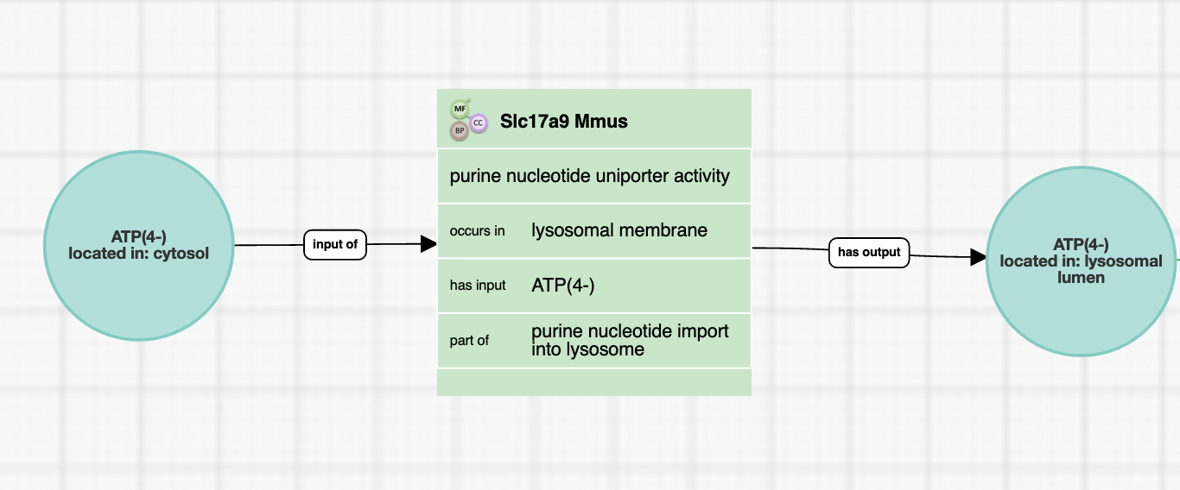

## 

## Form Editor

The activity unit for a transmembrane transporter is:

* **MF**: a child of transmembrane transporter activity [GO:0022857](https://www.ebi.ac.uk/QuickGO/term/GO:0022857)
* **Context:** The movement of the small molecule substrate is represented by:
  + 'has input’ the small molecule (ChEBI)
  + **BP** 'part of' the BP in which this transporter activity participates
  + **CC** 'occurs in' a child of membrane ([GO:0016020](https://www.ebi.ac.uk/QuickGO/term/GO:0016020)), e. g.: lysosomal membrane ([GO:0005765](https://www.ebi.ac.uk/QuickGO/term/GO:0005765))

**Example:** [**SLC17A9 transports ATP to the lysosomal lumen**](http://noctua.geneontology.org/workbench/noctua-visual-pathway-editor/?model_id=gomodel%3A63f809ec00001779)

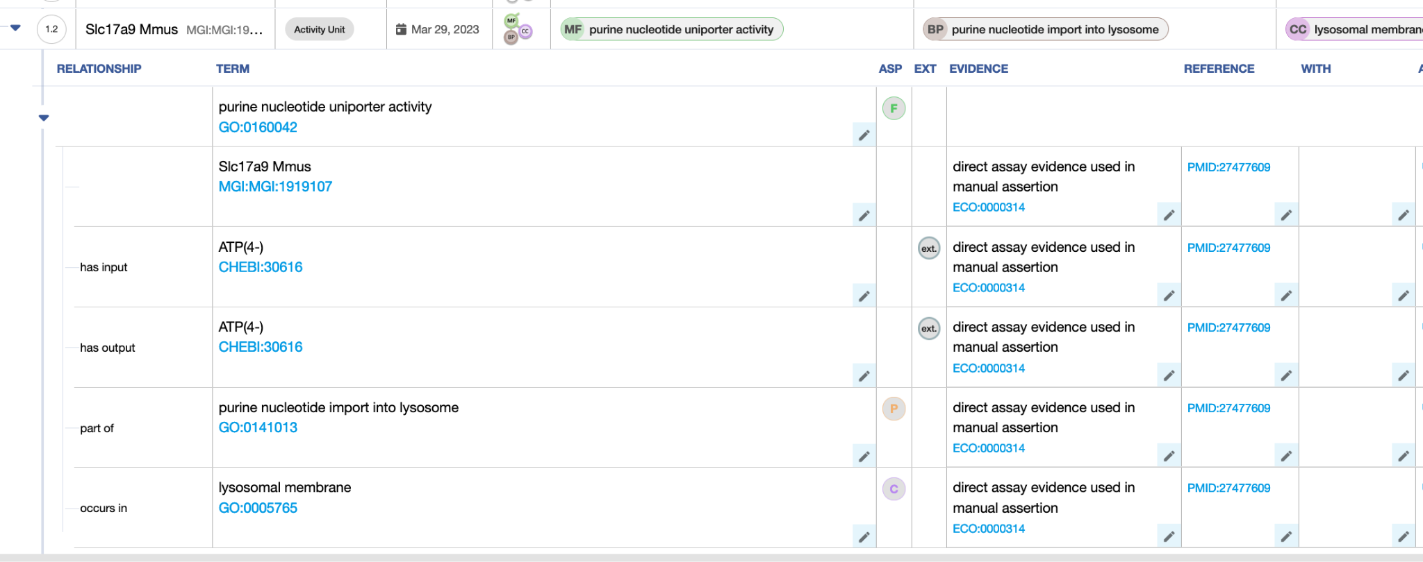

# Differences between GO-CAM and standard annotation of a transmembrane transporter activity

In standard annotation (captured with the Noctua Form or Protein2GO), the localization of the molecule is not captured; neither is the output of the transporter, since that output relates to the localization of the molecule transported.

# Review information

Review date: 2023-07-20

Reviewed by:Cristina Casals, Pascale Gaudet, Patrick Masson